Drug Addiction

Research and Design

Name: Michael Harrington
ID: C00296932
Supervisor: CM

Table Of Contents

Similar Applications: 2
Similarities: 2
Relevant Technologies: 2
Overall Architecture: 3
Major Interfaces: 3
Suitable Questionaire 4

Date: 28/1/2026

Similar Applications:
- https://americanaddictioncenters.org/self-assessment
- https://innerliferecovery.com/online-selftests/
- https://www.psychologytoday.com/ie/tests/health/addiction-test

Similarities:
- Anonymous survey results
- Multiple choice questions
- Clear disclaimer that results are not a diagnosis
- Links to professional help
- A clear privacy policy

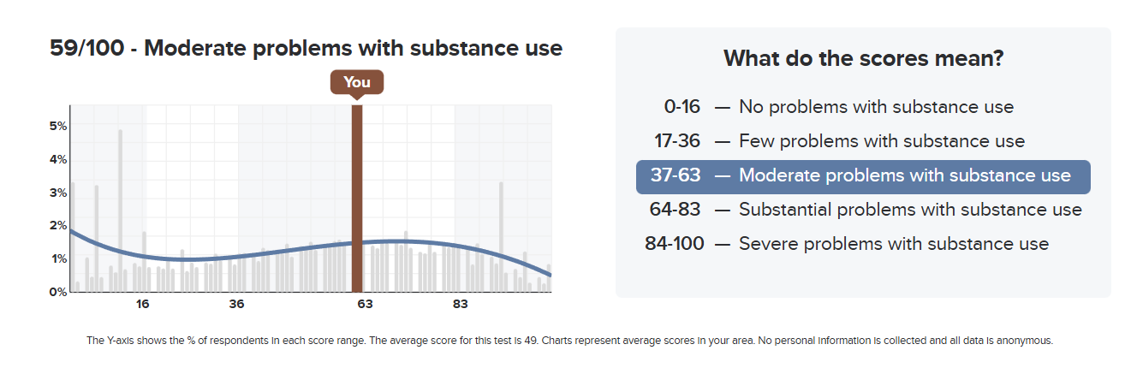

- This screenshot is taken from the results page of the innerliferecovery self test website. It displays a similar layout to the other websites i reviewed as well as what I plan my results screen to look like

Relevant Technologies:

- Mobile for Patients
- Desktop for doctors

Front end:
- HTML
- CSS
- Javascript

Back end:
- Flask

Database:
- MySQL

Overall Architecture:

Presentation:
Focuses on the interface that both the Patient and Doctor are using.

Application:
Focuses on the scoring of the surveys taken by the Patients.

Data:
Focuses on making the data from the survey secure and managing Patient consent.

Major Interfaces:

Patient Interfaces:
- Sign up/login
- Main menu
- Survey interface
- Results screen
- Consent screen

Doctor Interfaces:
- Secure Login
- Main Menu
- Patient Results Viewer

Suitable Questionaire
A suitable Questionnaire will contain appropriate questions related to the topic of the survey you are taking. For my Prescribed drugs and alcohol addiction survey’s, I will be getting most of my questions from the official Drug Abuse Screening Test as well as the Alcohol, Smoking and Substance Involvement Screening Test. The questions in these test have been approved by the World Health Organisation and are proved to be effective in pinpointing the level of your addiction.

